package school;

public class School {

public static void main(String[] args) {

}

}

public class Pricipal {

String name;

String Email;

String phno;

void displayalldata(){

}

}

public class Teacher {

String name;

String Email;

int id;

void displayattendanceofstudent(){

}

void displaymodificationinrecords(){

}

}

public class Employee {

String name;

int Employeeid;

String phno;

void displayattendance(){

}

}

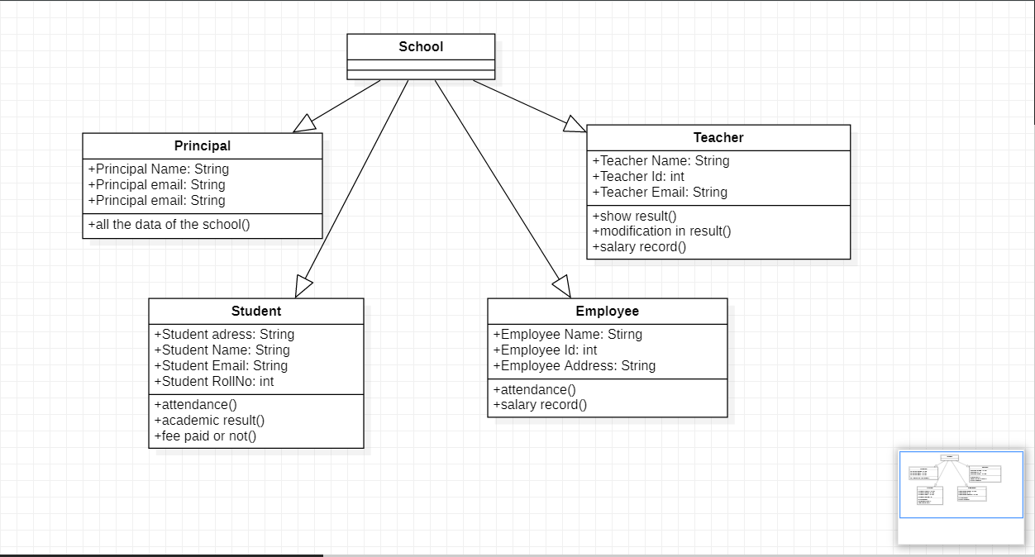

SCHOOL MANGEMENT SYSTEM UML DIAGRAM :)